Diary

# 6/05/2022

## What was in progress

I am currently looking for assets to go into the asset table. Then I will start working of the structure of the webpage. I have finished planning and doing a problem decomposition. This means I know when and what steps need to be done before certain dates. And having those same steps decomposed make sure I have a better understanding on what to do.

## How this matches the plan

The plan was just made so I am exactly where I said I will be.

## What is coming up next and possible obstacles or helpful ideas

I can see that gathering assets can take a long time. TO help with the lack of time I have for the whole website, I will time gate this talk to only take a certain amount of time.

## Feedback

I had the teacher look over some of the write up to see if anything was missing. This led me to add a few more sentences that ensures I talked about everything needed

## Screenshots of the page and code

No website yet

## Detail of checking stuff and testing

Nothing to test

## Details of trialling

Nothing to trial

# 13/05/2022

## What was in progress

I am currently building the structure of the website, and it is currently going well as nothing has stopped me from progressing. I also have started git hub. I currently have made an online repository that is link to this computer. This was done so work can be done at home if I need to.

## How this matches the plan

I currently am exactly where I planned I would be, this is because the project just started and there has been no issues building a structure.

## What is coming up next and possible obstacles or helpful ideas

For next week I will be making sure the structure is finished being made, this should be rather easy as it is almost done. Then I will be adding the content. This will need me to finish gathering content.

## Feedback

Nothing for this week

## Screenshots of the page and code

## Detail of checking stuff and testing

Nothing to test

## Details of trialling

Nothing was trialled this week

# 20/05/2022

## What was in progress

I currently have successfully made the structure of the page and it is completely resizable and has a maximum size for most computer screens. In this time, I also found assets and placed them into the asset table and processed them for later use.

## How this matches the plan

I currently am not exactly on time with plan as some things are finished a little later then expected. That being said I am not behind as I currently am adding assets and text like my plan suggests.

## What is coming up next and possible obstacles or helpful ideas

Having to write some text may take some time however the main obstacle that may present itself will be styling the website. This could be time consuming as things may not work or look nice. The best way around this is to section off places to style and I will also use save different versions as I go on to ensure that not all progress is lost if something goes wrong.

## Feedback

I have not asked for any yet

## Screenshots of the page and code

## Detail of checking stuff and testing

Nothing to test

## Details of trialling

Resizing the some of the header things, its not too much of a notable change but it sized for better use.

# 24/05/2022

## Update

Currently the slideshow is in development and it is being annoying as I cannot seem to get it running correctly as either none of the images show or all of the images will. I putting most of my attention here.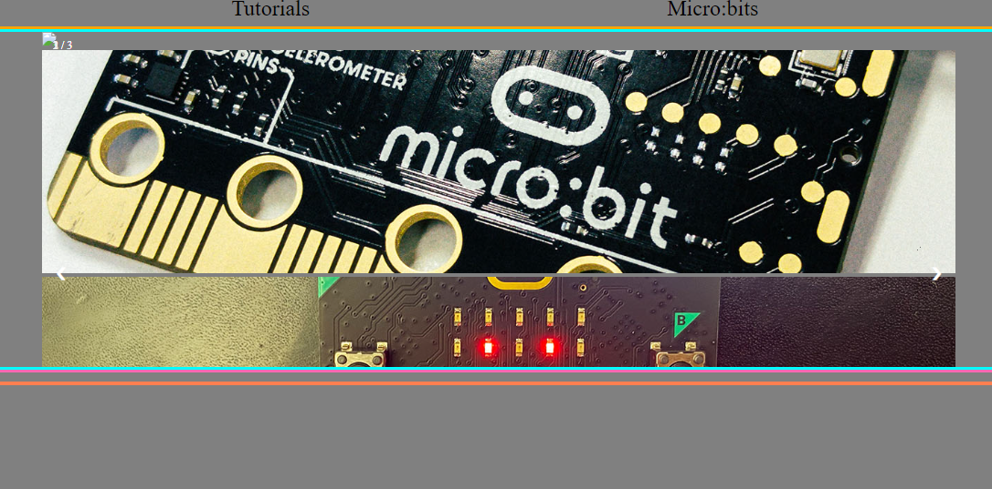

So an hour later I have found the problem it stemmed from the link between the JavaScript and HTML.

The code that failed

 <script src="/javascript/functions.js"></script>

Code that worked

 <script src="javascript/functions.js"></script>

# 26/05/2022

## Update

I have some styling problems on the slideshow so I will change some code by removing buttons and other additional things. This is because this slideshow is meant to be automatic.

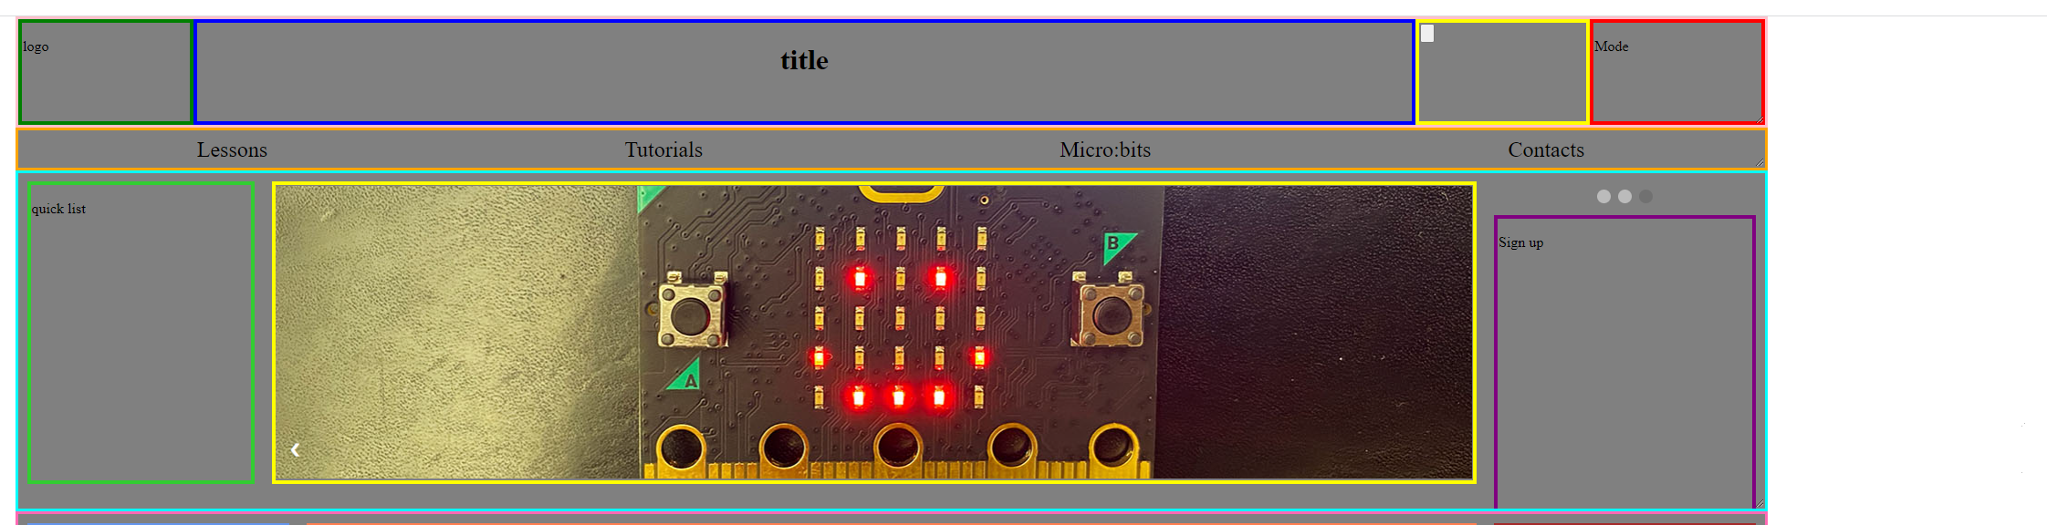

# 27/05/2022

## What was in progress

This week I was making the slideshow, this did take longer then expected however I was able to achieve making this. Then I was able it automatic and fix the structural issues it caused. Another thing I was able to do was add the images as well.

## How this matches the plan

I finished this late so Styling will only have 9 days to finish it. This may be really bad as styling can be hard and take a long time but, there is still a chance that it can be done early.

## What is coming up next and possible obstacles or helpful ideas

Styling will most likely take a while however this obstacle may be large or small it is completely dereddened on how many bugs or errors occur.

## Feedback

I did ask for help however I did fix before I got help.

## Screenshots of the page and code

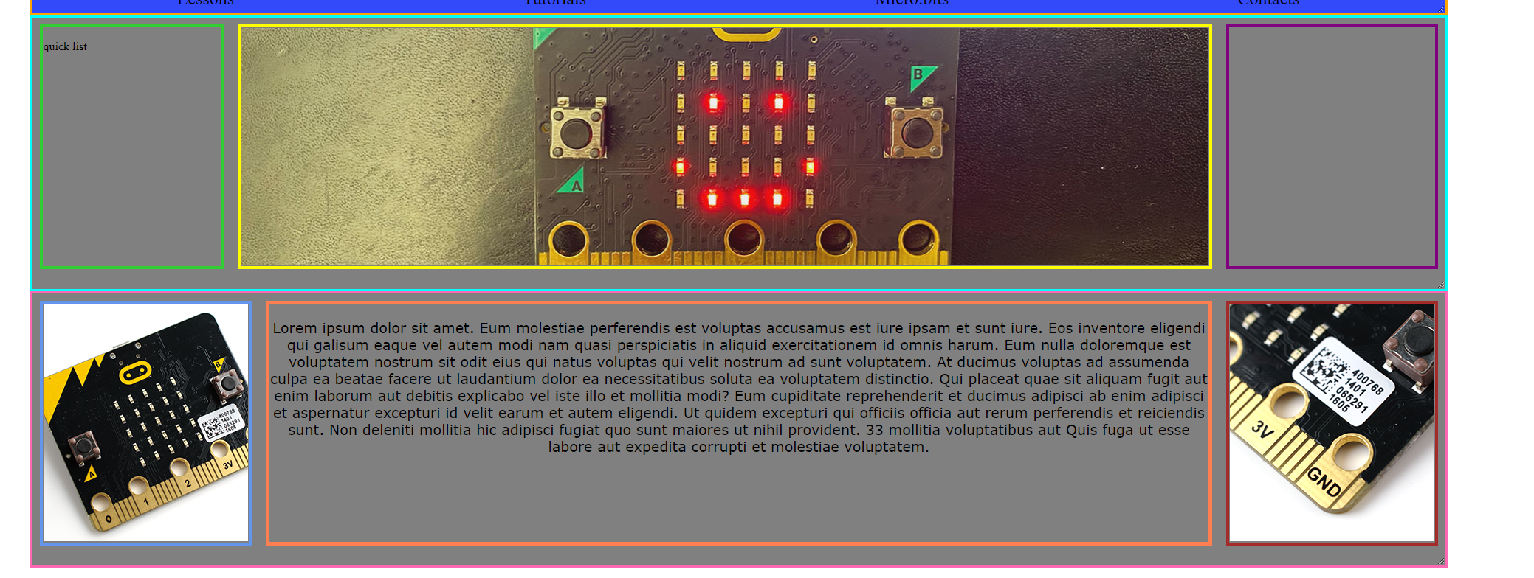 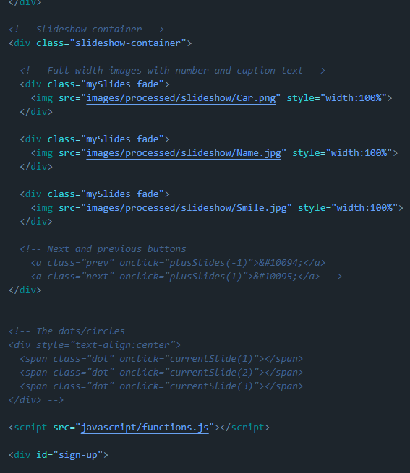

## Detail of checking stuff and testing

There was a lot of deleting no much of anything else.

## Details of trialling

None

# 3/06/2022

## What was in progress

This week I started styling and I managed to mage the header and the navbar, this primarily was recolouring. Then I started working on the dark-mode and I have been stuck into putting most of my time into it.

## How this matches the plan

I am supposed to be on the final day of styling however I am most likely going to go over a little time for this.

## What is coming up next and possible obstacles or helpful ideas

Styling will make me late however making the other pages will be rushed

## Feedback

I asked the teacher for help for JavaScript however I we are still developing a solution.

## Screenshot of the page and code

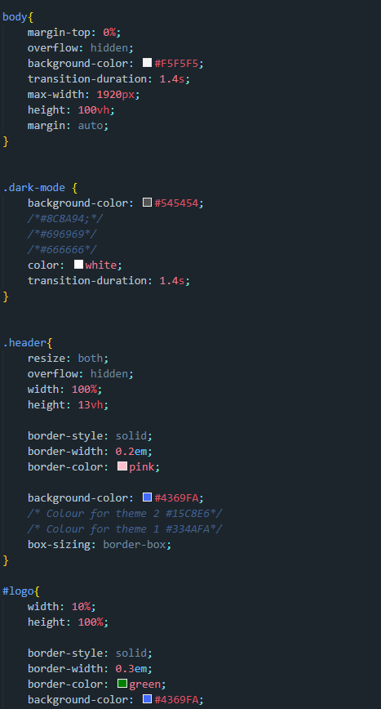 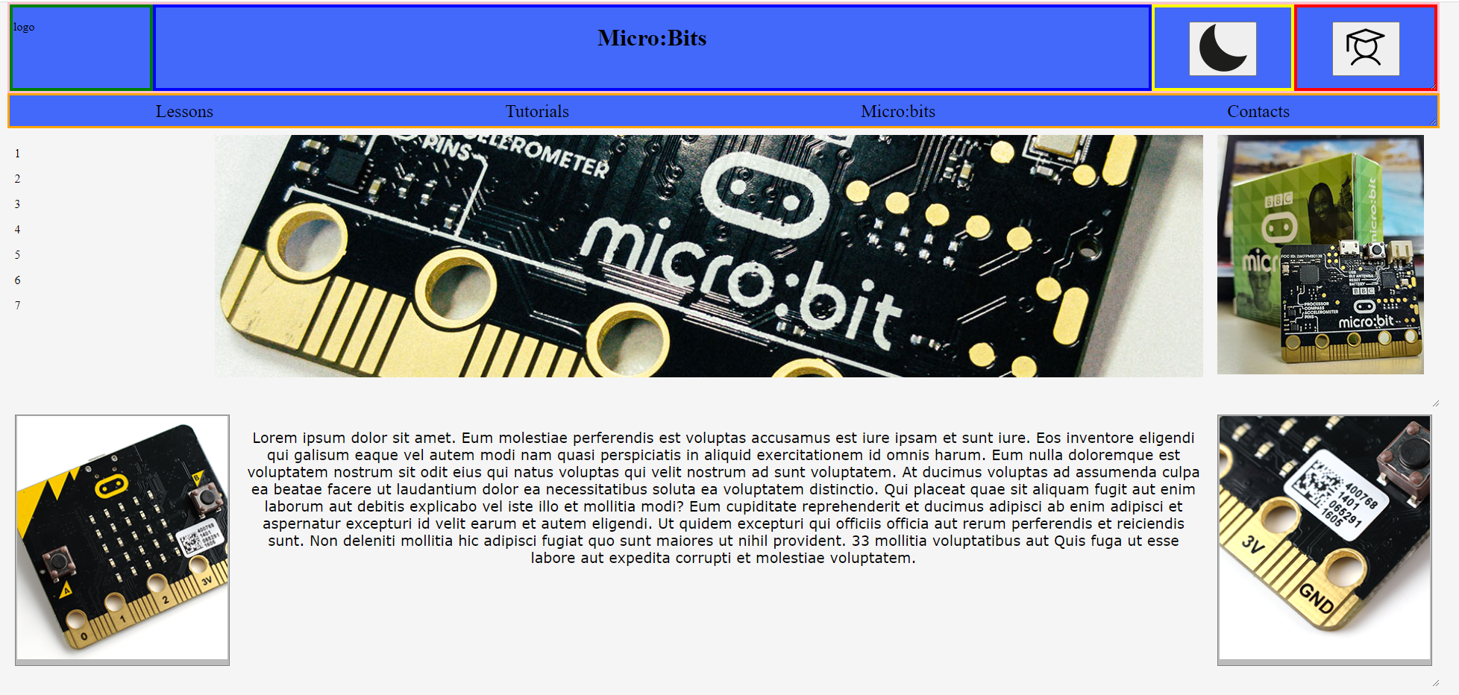

## Detail of checking stuff and testing

There was a lot of testing done for the dark-mode however it is still not done.

## Details of trialling

None

# 14/06/22

## What was in progress

This report was not done on a Friday as the place where I live had some of the worst weather I have seen in a very long time. For my safety I was not able to attend school on Friday and Monday, this did mean I worked from home. This time at was used for finding problems and solutions in the current version of the code. This has allowed me to learn how to use JavaScript Storage to allow for the use of Memory in the website this will be a key factor in the final product of the design. Other then that I touched up the website by fixing things that looked weird, or that were broken.

## How this matches the plan

Not very well as I am behind on creating the other page however I am almost they’re as the styling is basically done.

## What is coming up next and possible obstacles or helpful ideas

Putting in content for the main and other pages, this will be done by prewriting and gathering images before I need them.

## Feedback

None so far, However I asked the teacher to look at some troublesome code.

## Screenshot of the page and code

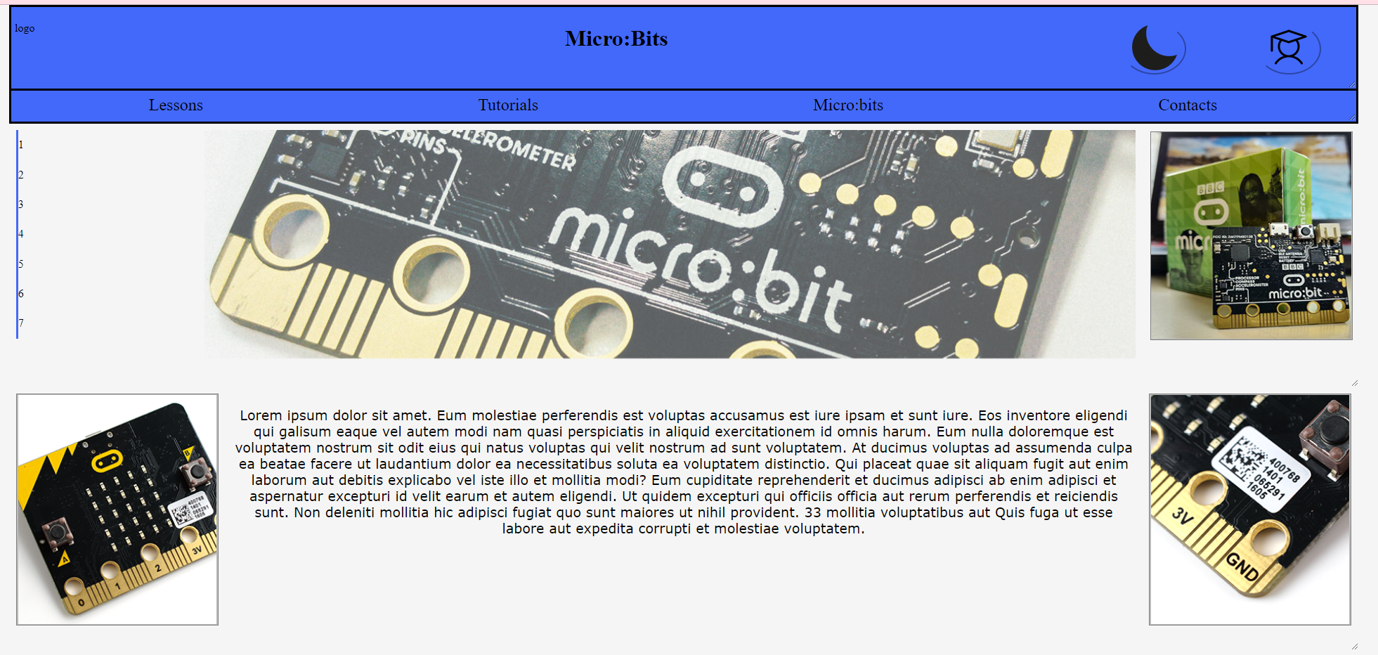

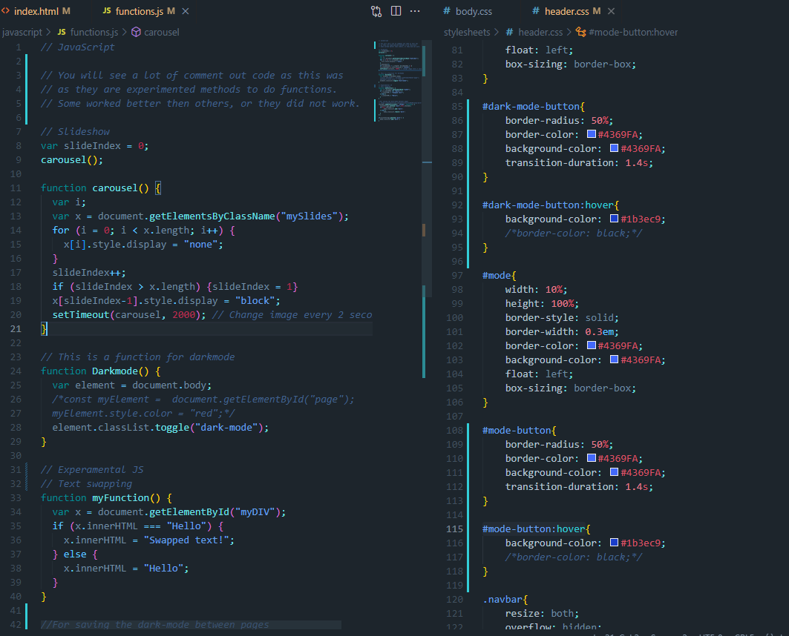

## Detail of checking stuff and testing

This week was moving things in the right spot and tweaking it a little, however I have tempered with JS a lot as I desperately need it to work. The comments show all the tried code

## Details of trialling

I have not done any currently.

# 17/06/22

## What was in progress

This week I started making the second page. The stylesheets and JavaScript integrated easily without any problems. I did make a third stylesheet for these other pages as they will use a different layout then the Main page. This week I have also been trying to learn how you use JavaScript between HTML pages. Although there are no visual results, the console seems to confirm that it works. So, expect this feature to work soon. I have also been in contact with the teacher about a styling issue I have been having and he showed the solution very fast and it was quick fix.

## How this matches the plan

This stage where I am at does match where I am supposed to be on the plan, however I am still behind as in I still have six days less on this stage then there was supposed to be. But building structures from a template that I already made should be very easy. That is why this stage was extended as the styling may have taken longer than expected.

## What is coming up next and possible obstacles or helpful ideas

That next stage of development is to add more images and add all of the text to all of the pages. Which means I will grab more assets and I will have to do a lot more writing. This will take a while as there is a lot to write but it is not impossible.

## Feedback

There was no actual feedback but I did get some help solving the CSS problem from the teacher

## Screenshot of the page and code

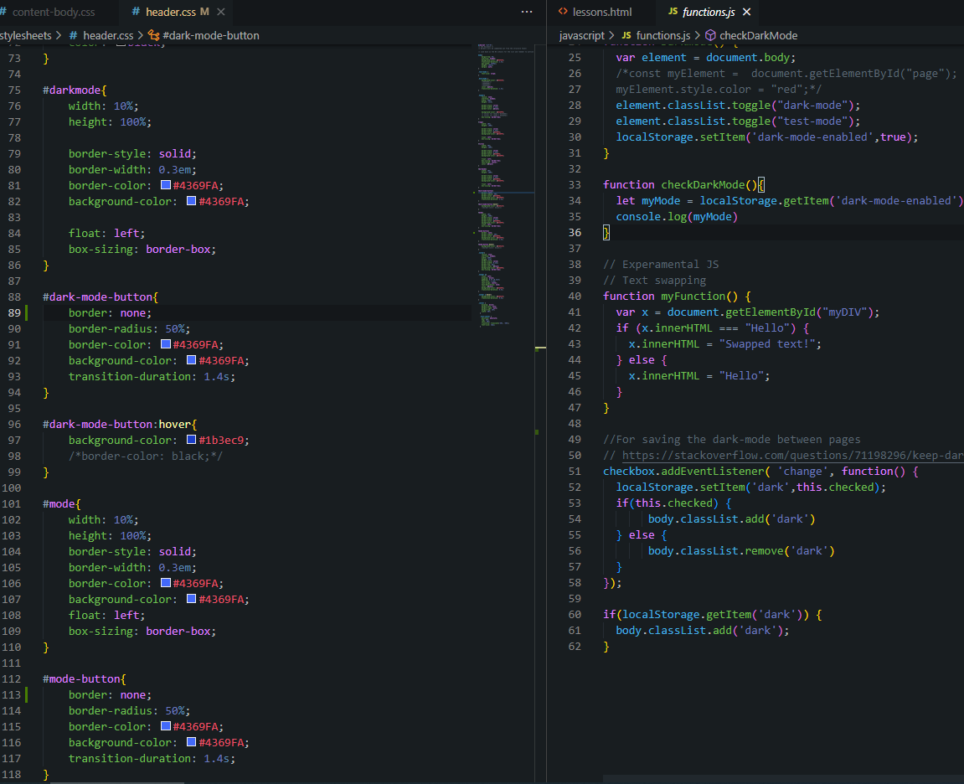 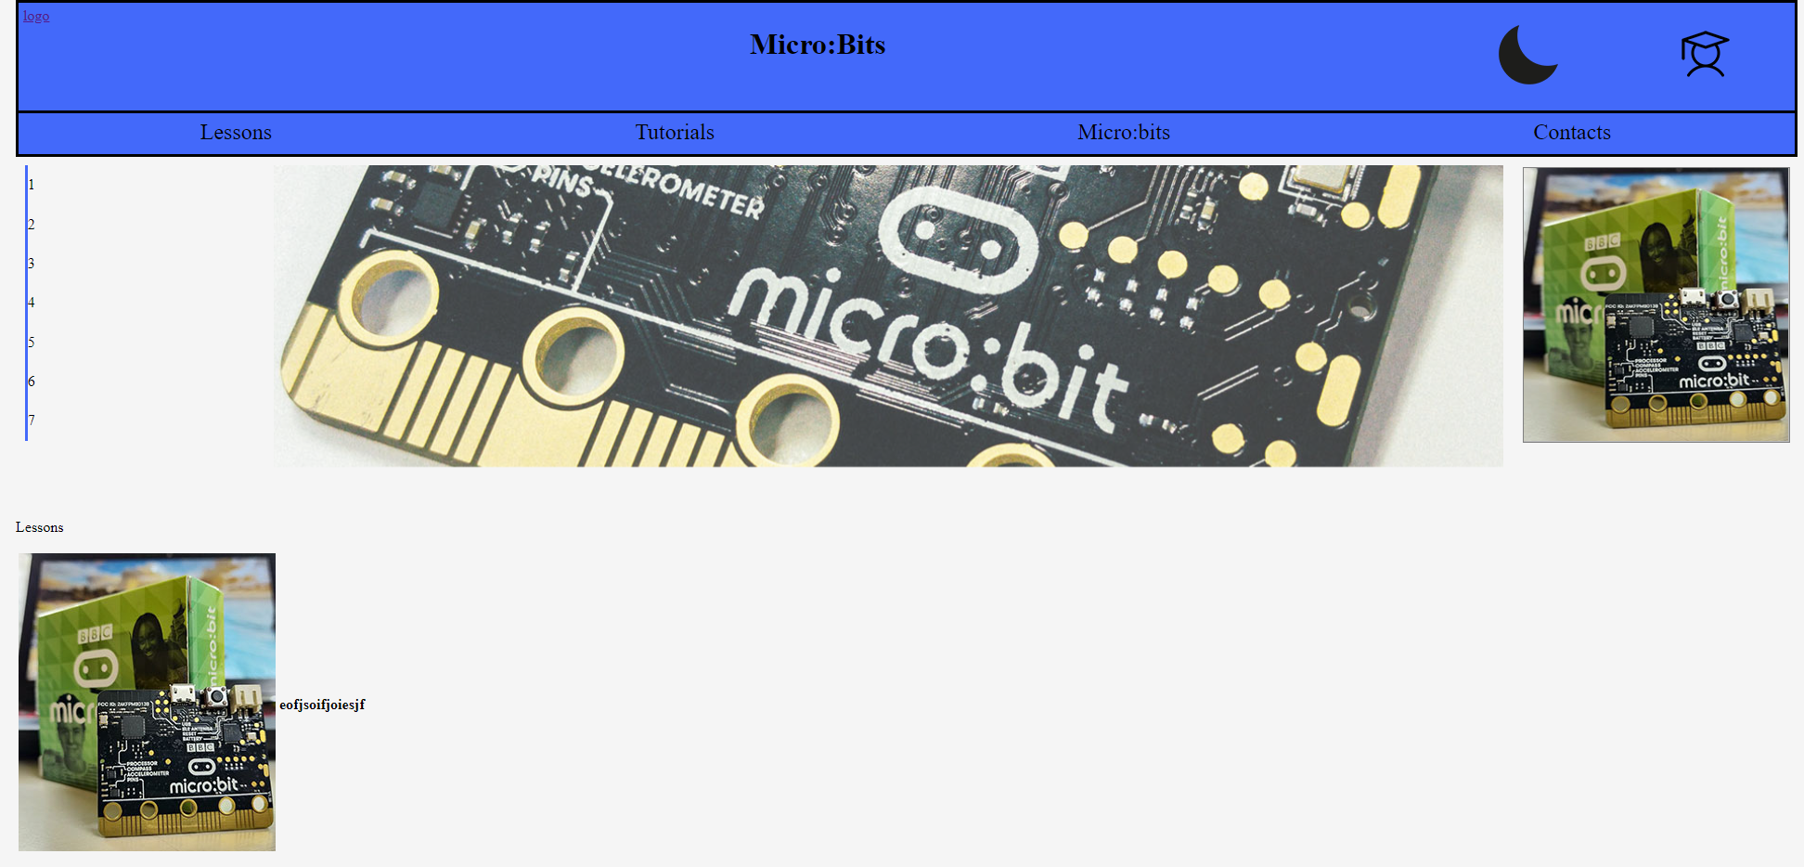

## Details of checking stuff and testing

The JavaScript file has been edited a lot and there are a few lines of code for debugging, that’s where most of the debugging.

## Detail of trailing

Mild script changes that make some stuff work a tiny bit differently

# 21/06/2022

## A Plan

So, for one of my main features of the website there is a button that change the content and look of the page depending on what mode you are on.

After talking to the teacher about CSS I learned CSS classes cannot directly change each other. I would need a new CSS file with change in it to be called which then should allow me to make all the visual changes I would need.

To do this hairbrained scheme I will use some JavaScript to call a file instead of a Class. Which I currently do not know if it works or not.

**Trialling the dark mode operation**

The JavaScript before adding to it. This toggles the dark mode but it would n’t go across pages. I had top try some other ideas out. Also it couldn’t do all of it at the same time so the header didnt change. I need to try out al alternative technique.

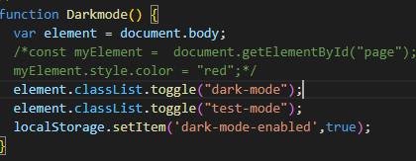

What I will be doing is making a new class the looks relatively the same and it will be name modeChange. The important part of this code is the element.classList.toggle(“”); as that should hopefully toggle between files.

Added JavaScript

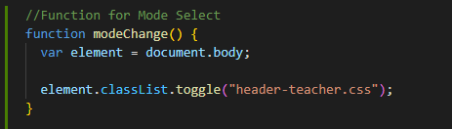

Test results:

It does not work, and from what I can tell this method only will work for classes, not full file changing.

So I need to try yet another technique

After doing some research I now have this template for the JS

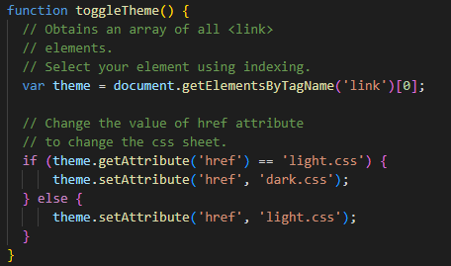

So after a quick test it half worked, it did toggle to a different sheet but it also did style anything properly.

# 23/06/2022

After a chatting with the teacher and him taking a look at the problem he sent me code that looks Identical. So, I adjusted it a bit so it looked like this instead.

This technique that I found worked on the secondary pages but not the other pages. So I am a step towards the better technique but not there yet.

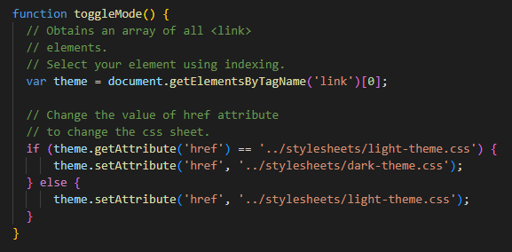

This does work however it only works on the secondary pages not the main page.

While talking to friend while working on this issue I realised that I need to make a new function that looks identical how ever there will be slight adjustments

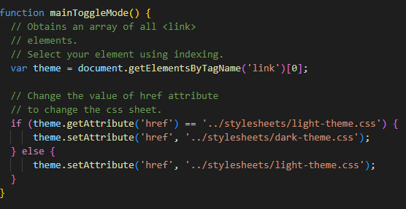

This does work with all pages now.

Finally I have tried out a technique that gives me a solution for al pages.

# 24/06/2022

## What was in progress

So, this I worked on the JavaScript all week to make it able to change themes and go across files. I did make the theme change possible however the using local storage has been slow and I have not achieved that part yet. However, I also moved the slideshows JavaScript as I that would remove errors from the page

## How this matches the plan

This does not as the plan is fully improv now as I am rushing to get everything done

## What is coming up next and possible obstacles or helpful ideas

Getting the content written and images gathered will be the obstacle but that is what I will need to do at home

## Feedback

None

## Screenshots of the page and code

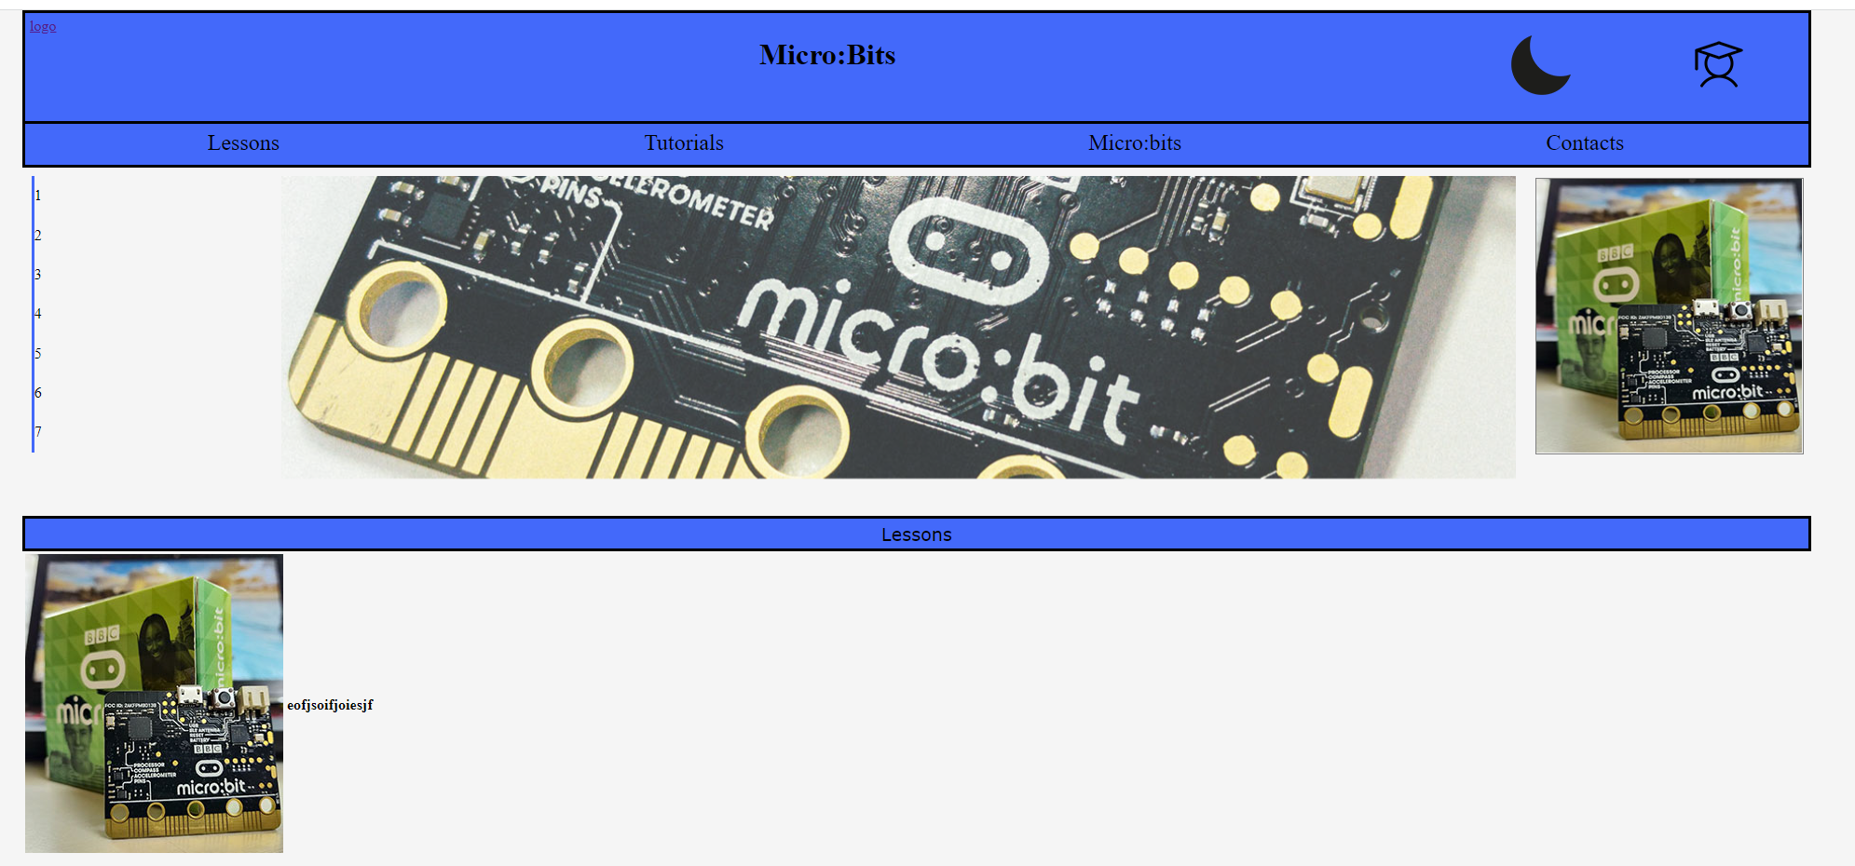

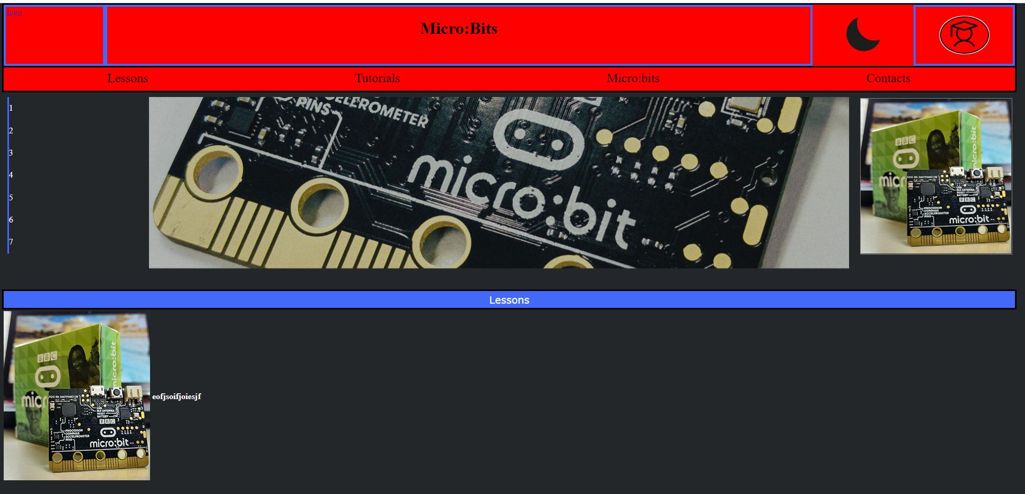

Bare in mind the recolour has not been styled yet.

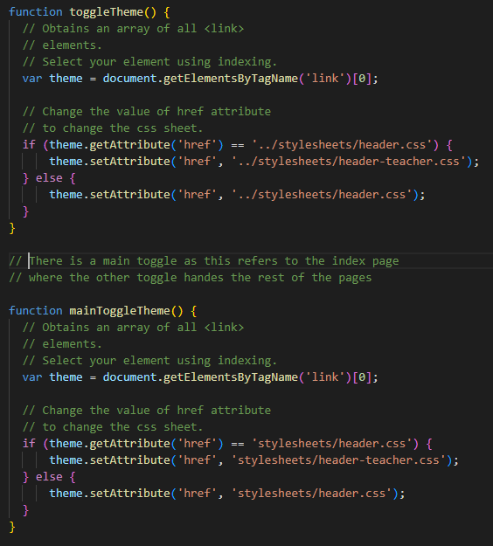

## Details of checking stuff and testing

Look at the stuff from 23/06/2022 as there is a lot of the testing and debugging. However, you can see other versions of the code in the comment inside the JavaScript file

## Detail of trailing

There will be lots of commented coding however there is a lot of console.log() usage to see where and what the page is registering

# 01/07/022

## What was in progress

I was mostly working JavaScript which has led the content to be made at home however the JavaScript kept having multiple problems. These consisted of buttons not working, linking incorrectly or JavaScript that was coded wrong.

## The Plan for the last week

The Plan is to make and do all the documenting at school with extra code on the side where the content creation will happen at home. Testing will happen whenever I can do it Home or at school.

Most of the testing am doing at the moment is to track down minor glitches such as the link list would move on its own.

## Feedback will be gathered next week for last minute changes

## Screenshot of the page and code

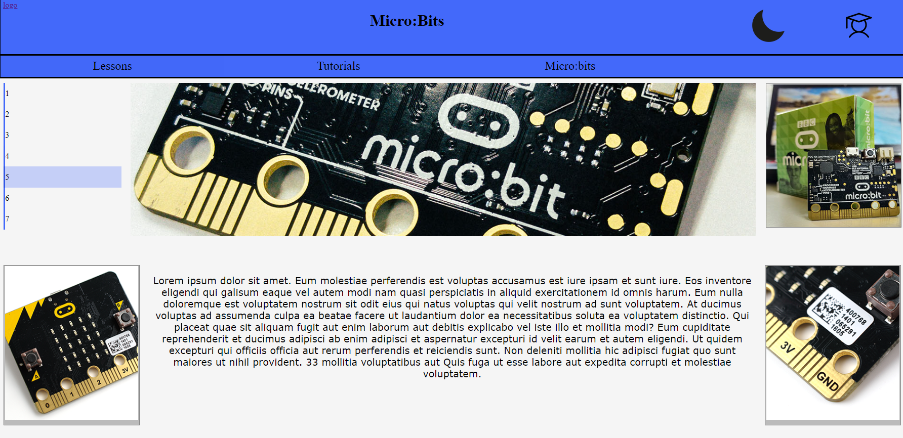

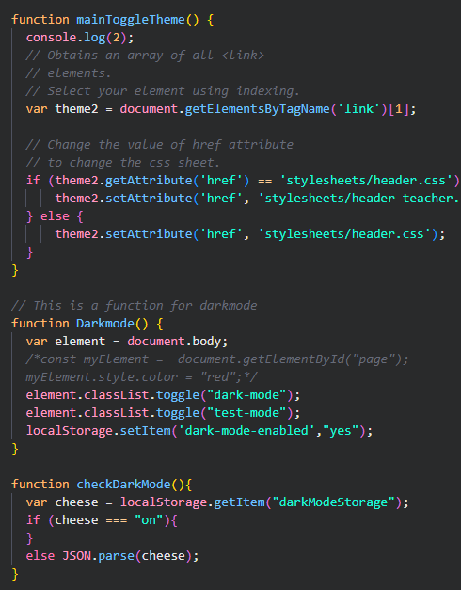

## There was no real testing of the page.

## Trailing

This weak had a lot. I went through multiple versions of JavaScript until I had a idea where the var element = link chose which link based on the number given. In this case Dark mode functions must use the number 0 where theme changes used the number 1 to represent which one was used for each function. This meant the original code was not wrong except for one integer value.

Blake also gave me the understanding that Local storage uses Strings and nothing else and had informed me you can still use numbers the same way, however you just need to declare them as a String

# Weekend Coding

## About us

The first thing that was done was to start and finish the about us page. This was a very easy task as all this page needs to do is talk about who made the website and the two key things for the end-user. Copyright and Privacy. I explain to the end-user no user data is collected without permission and that all data collected is securely stored. For copyright I said to refer to the gallery to see the credits to the images. I did also check with some users to see if the layout and design was ok. So I was assured that this is good design for an about us page.

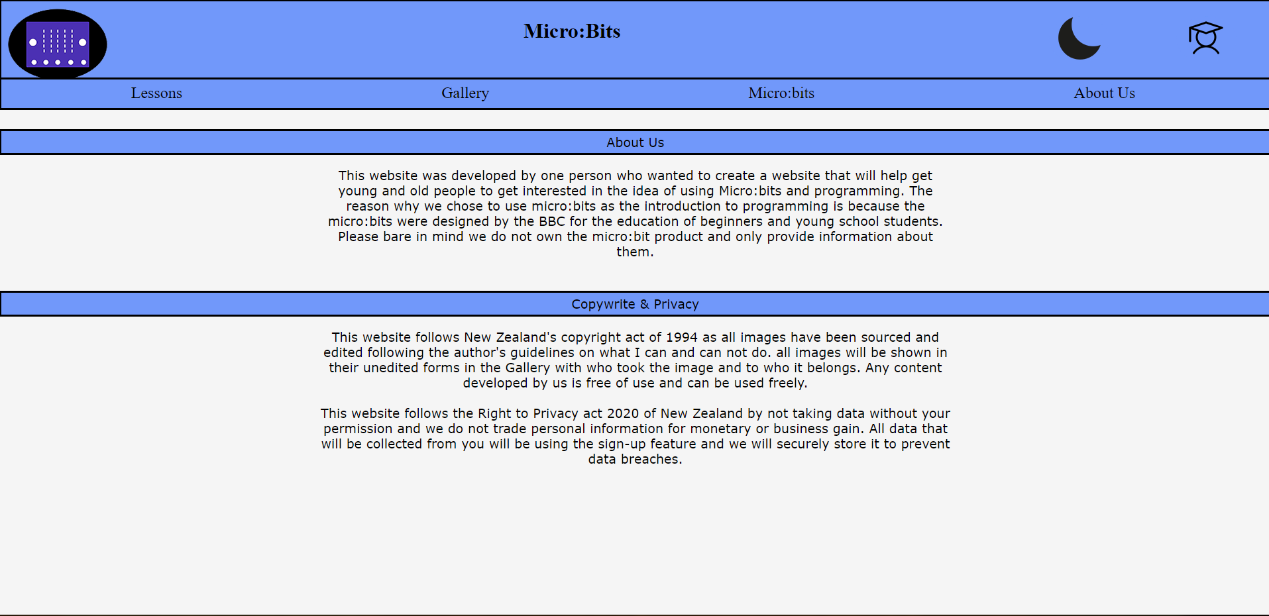

## Quick list

This was list is a list of valuable websites for end-users to get better at Micro:bits. This was easy as I was just putting links into the list as the structure was already built.

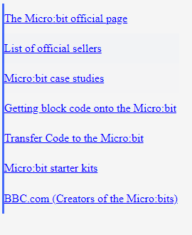

## Text swapping

This took a long time however I just used a similar structure to the stylesheet changing however this is only used on the Lessons page of the website. The Student text will be found in the HTML and the Teacher text will be found in the JavaScript in the textSwap() function. This screenshot is the template so you can see what it looks like.

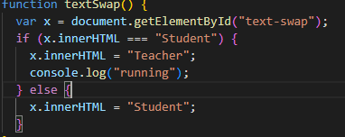

## Filling in the content

This started on the Micro:bit page. This is just a description of what a Micro:bit is and what in can do and what parts it has. This is not hard and will take a little longer as writing text takes a while, as well as using photoshop on images.

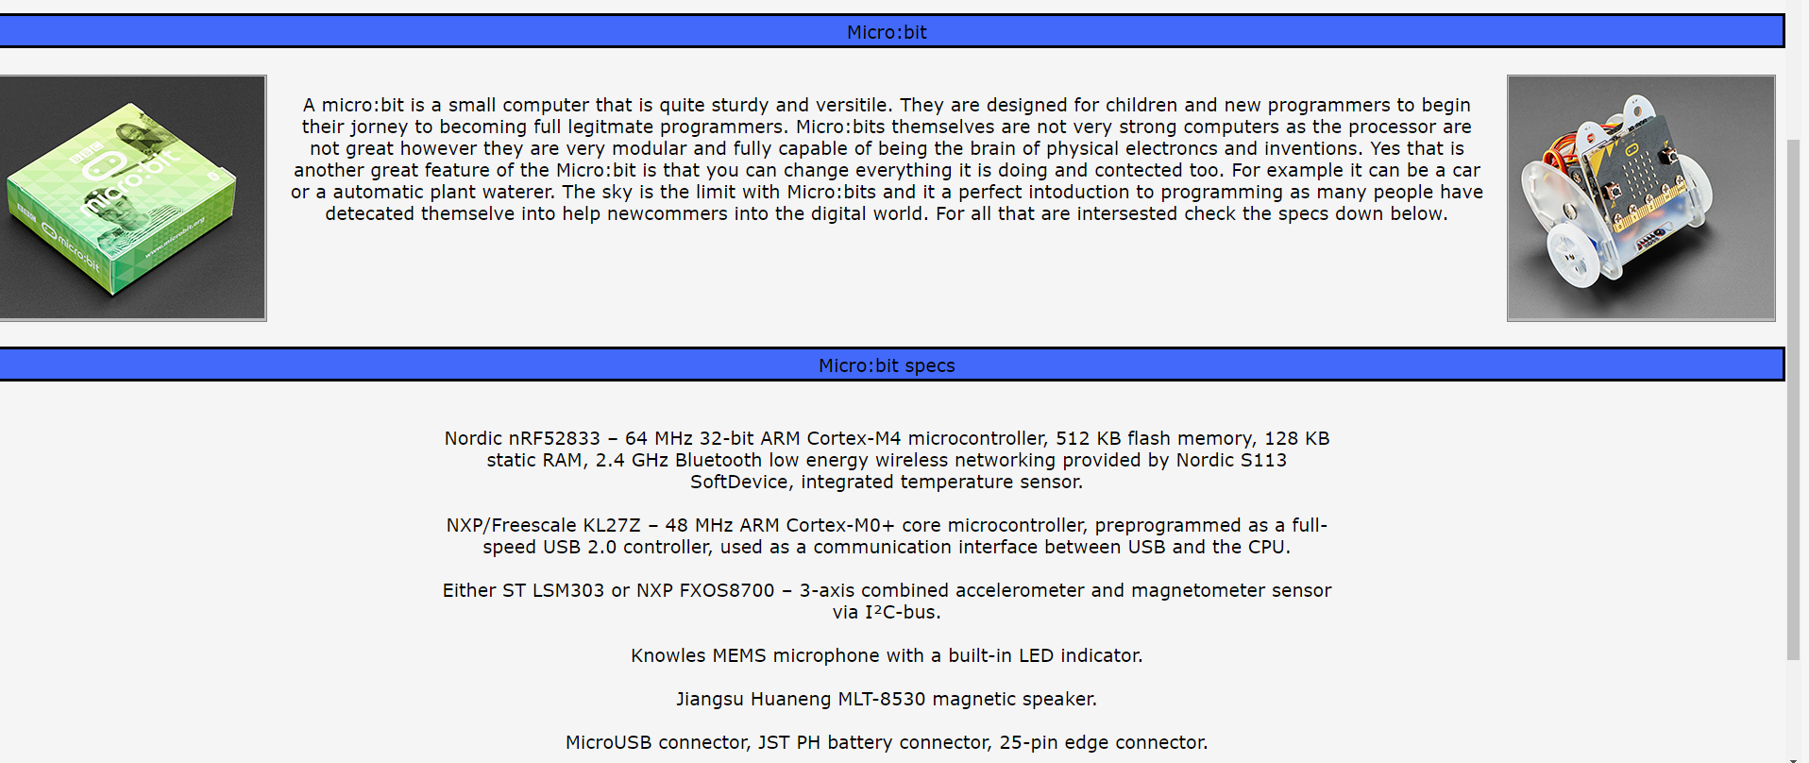

I then moved on to the Gallery page as that should be the fastest page to complete as the images will be edited (This is ok due to the rule I was given by the authors) and credited to obey the copyright act of 1994. All image that are not in the Gallery are not in the asset table as they are images directly taken by me

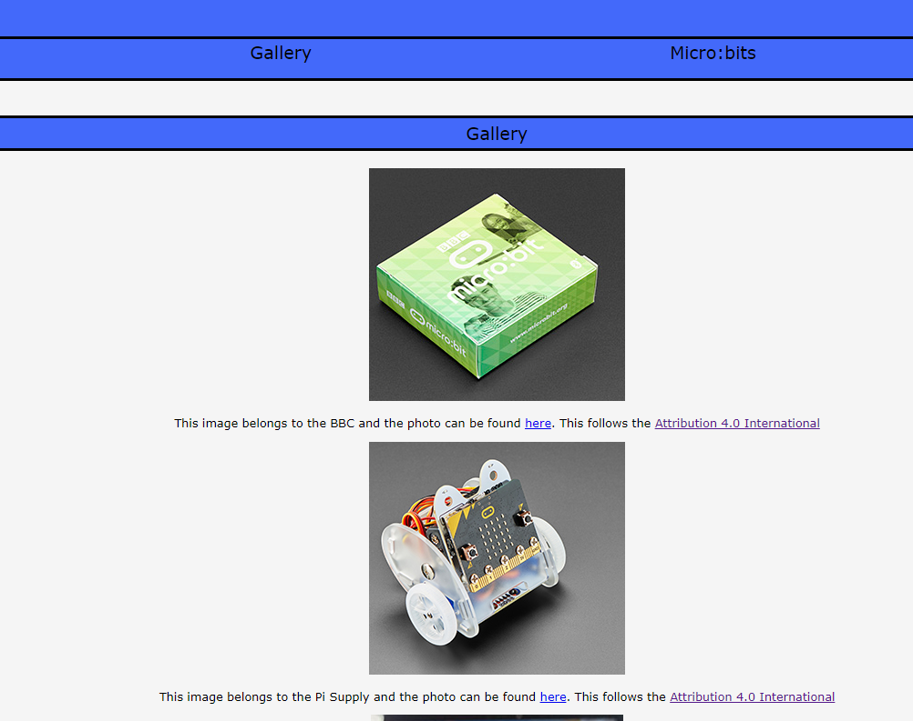

The lesson page will be the last page done as this one requires two sets of content as one Is for teachers the other is for students. Although the lessons will be the same in what they will be doing. The information given to the end-user will be different depending on what mode they are in as it will be tailored for what they are. This is what the final page looks like.

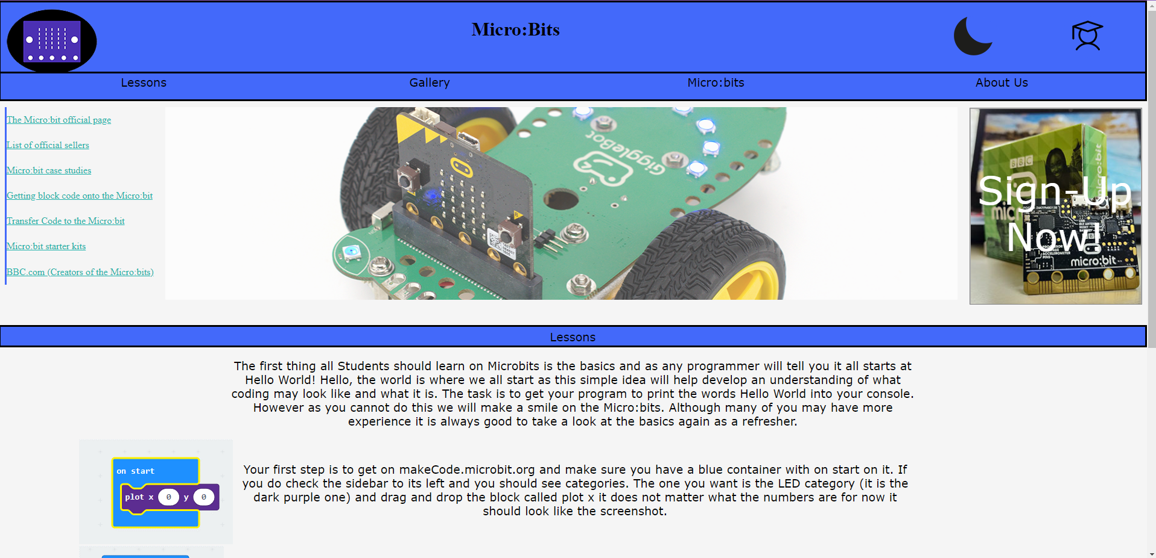

Final glitch fixing.

There were many issues caused by resizing the webpage. The pages most effected by this was the Micro:bit and the lessons page. This because all formatting or image sizing would be distorted and be position incorrectly. Another problem was the quick list not having correct resizing either. I fixed these three problems in different ways. The Lessons page’s content was completely reformatted into a table. This because having large amounts of divs that are in separate containers added too many variables that can move when resizing the screen. So, by making it a table They were a contained in a way were they always aligned with their respective images and also prevents them from moving unexpectedly. The micro:bits page was fixed by separating the micro:bit specs from the description above. This separation was done by putting them into different div containers making it impossible for the content to overlap. There was a few cases of the margin form the higher container moving text but it was fix by moving the margin. The quick list was very easy fix as I new shrinking hyperlinks was out the question so I hid the overflow so the list stays uniform the smaller the page gets. Logo and image resizing was also a fast fix as I created class called image-resize which does not effect styling of the image but it will resize them when the page is shrunk

## Test table

I developed a test plan for things that needed to be tested before I would say it was finished. This test plan can be found in the admin files. What it looks like.

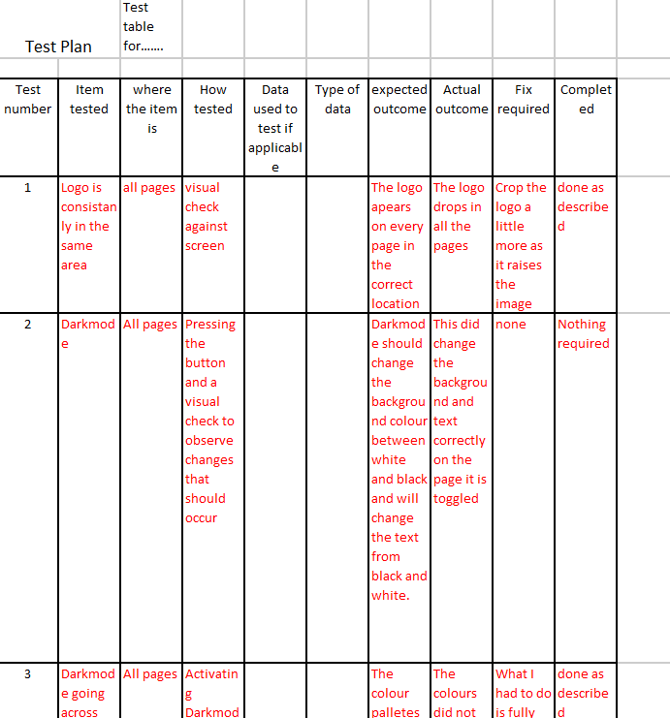

## W3.org validation

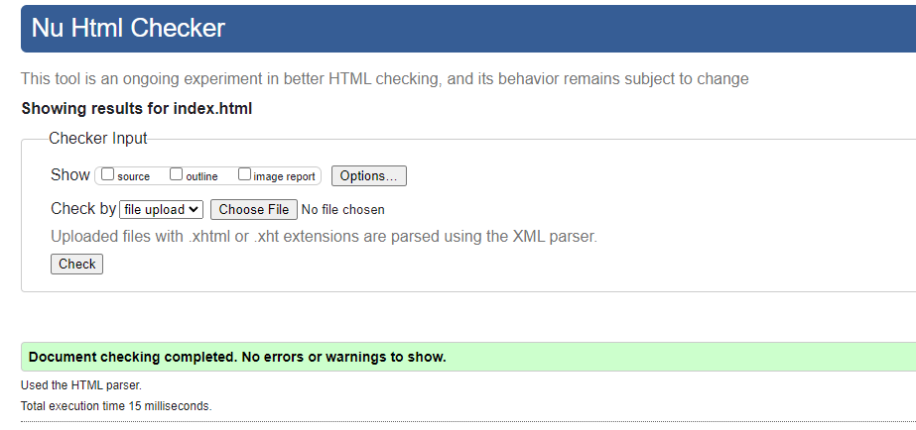

My page was test and seems to be all good and the validation saw no errors.

This proof that testing improved the outcomes and caused the file to have either very minor or no errors at this current moment of time. If I did not test I may have had a large amount of errors and causing more work to happen that was not needed.

Some early versions of the website is stored in the admin folder it is recommended that you check the GitHub repository as it has a very large number of save and different versions of the page.

[CoetzJu/13DGM (github.com)](https://github.com/CoetzJu/13DGM)